

Written by:

**CEN5035 – RESULT Team**

**Ashish Arora**

**Yom Chouloute**

**Christopher Foley**

**Divyang Purohit**

**Venkat Retesh Velapakam**

# Academic Year: Fall 2016

Table of Contents

**Team** 3

**Team Contribution and Peer Evaluation** 4

**Purpose motivation and Product Goal** 5

Overview 5

Product Goals 6

Targeted Users 6

**Screen Shots** 7

Mockup Screen Shots 7

**Screenshots of the Final System** 8

Ad Hoc Submission 8

User Registration 9

Login 10

User View 11

Dispatcher View 12

Local Staff View 13

Third-party View 14

Manager View 15

Prize Finder Search 16

Location Management 17

**BPMN Diagram** 18

Overview BPMN Process with all entities and actors 18

Sub-process of User Accessing **EDU*Snap*** site 19

Sub-process of dispatcher’s accessing the site 20

Sub-process of FAU Repair Staff accessing the site 21

Sub-process of Third Party Vendor accessing the site 22

Sub-process of Manager accessing the site 23

**Scrum Project Screen Shots** 24

**Features** 25

Finished 25

Unfinished & Wish List 25

**Knowledge Gained** 27

# **Team**

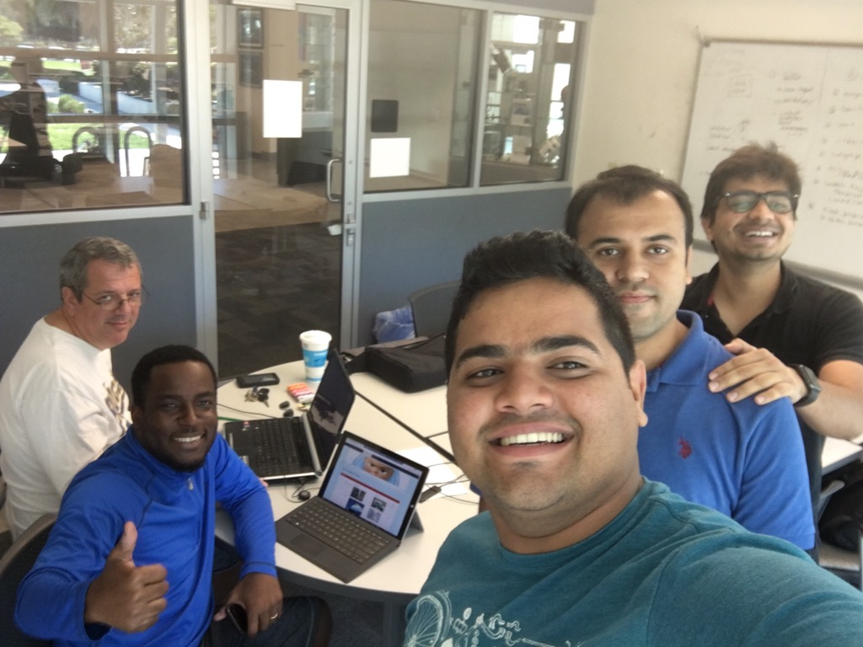

**Ashish Arora** – Product Developer

**Yom Chouloute** – Scrum Master

**Christopher Foley** – Product Owner

**Divyang Purohit** – Product Developer

**Venkat Retesh Velapakam** – Product Developer

# **Team Contribution and Peer Evaluation**

The team after discussion has chosen to allocate our weighting as follows:

**Ashish Arora** – 20/20

**Yom Chouloute** – 20/20

**Christopher Foley** – 20/20

**Divyang Purohit** – 20/20

**Venkat Retesh Velapakam** – 20/20

We implemented five major use cases for the **EDU*Snap*** project and each one of us worked on a use case. Ashish Arora worked on the third-party use case, Yom Chouloute worked on the local Staff use Case, Christopher Foley worked on a dispatcher use case, Venkat Retesh Velapakam worked on the manager use case and Divyang worked on the User use case. We designed and implemented the rest of the features (database included) as a team. The scrum master worked on putting everything together.

# **Purpose motivation and Product Goal**

## Overview

Universities and schools are not small places. Take FAU as an example, this university covers approximately 850 acres. To give you a little perspective, the dimension of a football field, including the end zones covers approximately 1.32 acres. Hypothetically speaking, you can fit 644 football fields inside FAU.

Administrators and facilities employees at these large institutions usually do their best to provide students with a clean, hazard free and a safe environment. They have employees assigned to maintain each region on campus, they use video cameras and the help of the police department to survey all areas.

Although Administrators and maintenance staffs do their best, there is always room for improvement, since it is quasi impossible to monitor every corner on campus.

Introducing “**Edu*Snap***” a responsive website created by a group of students at FAU that can make it very easy for anyone on campus report issues that require immediate attention.

We are hoping to add to a link to our responsive site in the University mobile App. Doing so will make it very easy for everyone to access the application.

## Product Goals

* Easy to use (Ability to create a ticket in less than 30 seconds)
* Ad Hoc Ticket Submission for faster ticket creation
* User Registration if our users want to track their own tickets
* Different view for each user type
* Email Functionality
* Point system and prize for the person who reports the most completed tickets.

## Targeted Users

The following users are targeted as users of the intentional system:

| Name | Brief Description |
| --- | --- |
| Dispatcher | Responsible for prioritizing and dispatching field technicians to repair observed anomalies. |
| Technician | Individual who completes the repair |
| Third Party Vendor Staff | The Third Party Vendor Staff is a third party agent outside FAU Campus which accepts requests from FAU Dispatcher staff if repair is not being provided by FAU repair staff and confirms the request after visiting the site which needs the service. Once the repair is completed Third Party Vendor uploads the picture of task completion on Edu Snap application and notifies the dispatcher. |
| Manager | Check reports for work done and give away awards to users who have actively reported messages. |
| Student | Responsible for reporting incidents like repair and damages on campus |
| Staff | Responsible for reporting incidents like repair and damages on campus |
| Visitor | Responsible for reporting incidents like repair and damages on campus |
| FAU Repair Staff | This staff is responsible to fix the issue reported by the users of the **Edu*Snap*** application |

# **Screen Shots**

## Mockup Screen Shots

Due to the time constraints of learning a new tool, see Lessons Learned page 27, it was decided to rely on traditional methods of interface design which allowed for more rapid implementation as evidenced by the following:

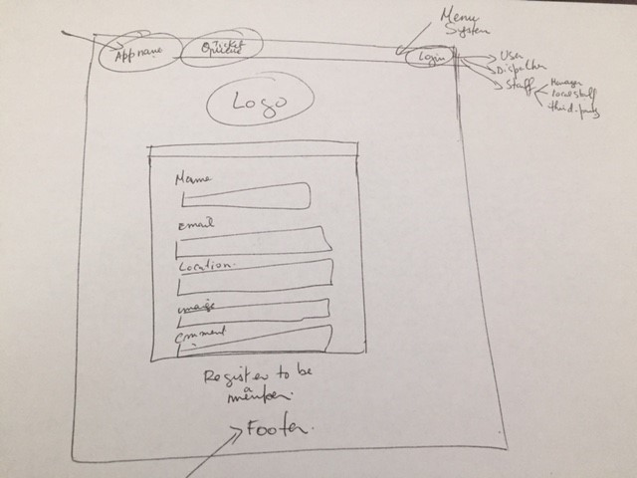

# **Screenshots of the Final System**

The following screen shots were taken for the final presentation:

## Ad Hoc Submission

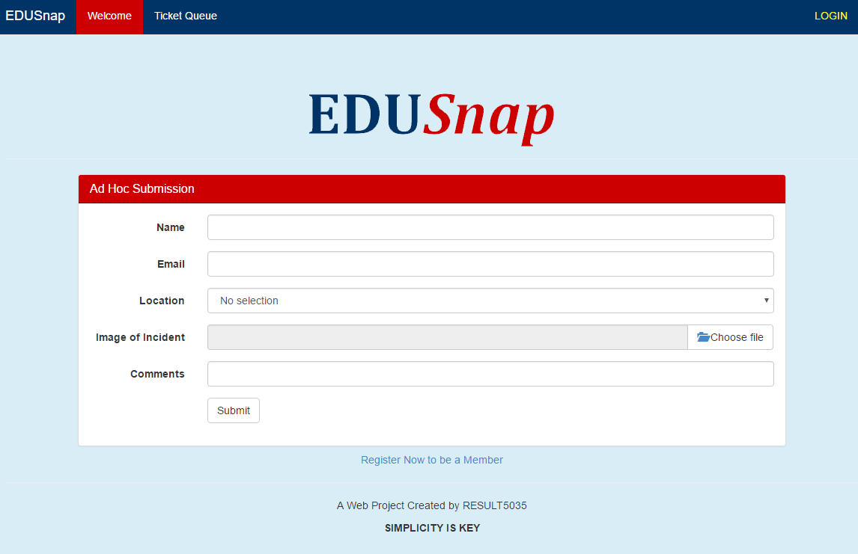

## User Registration

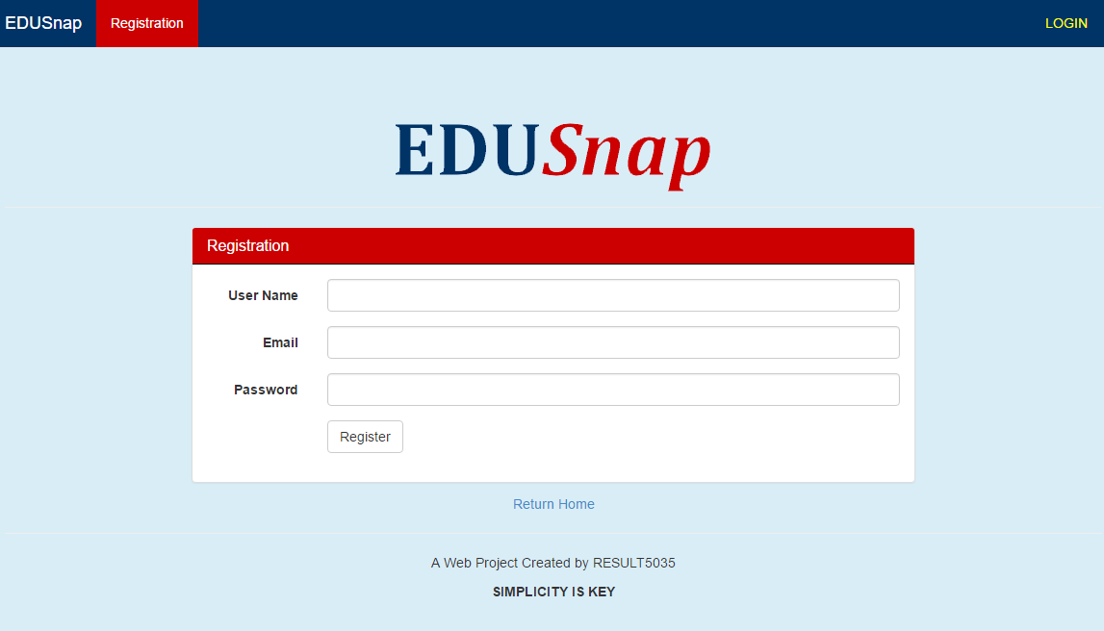  
  
User Ticket View

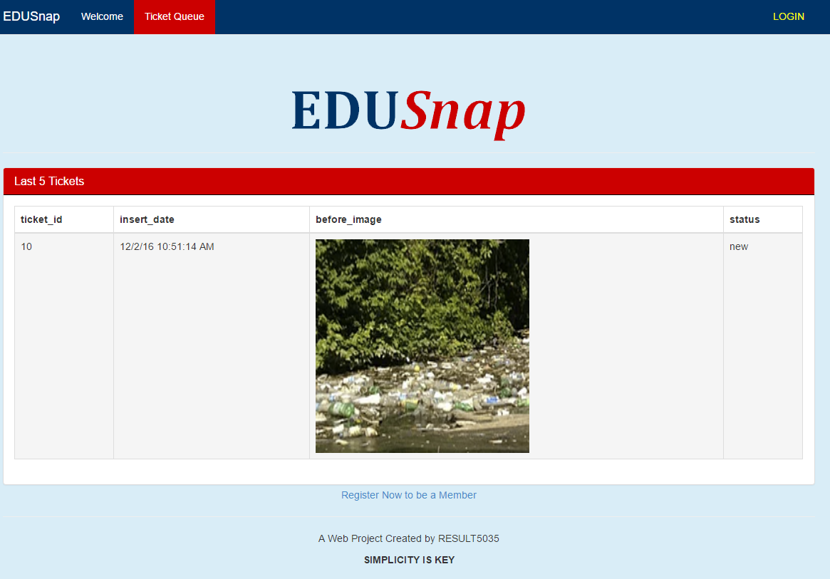

## Login

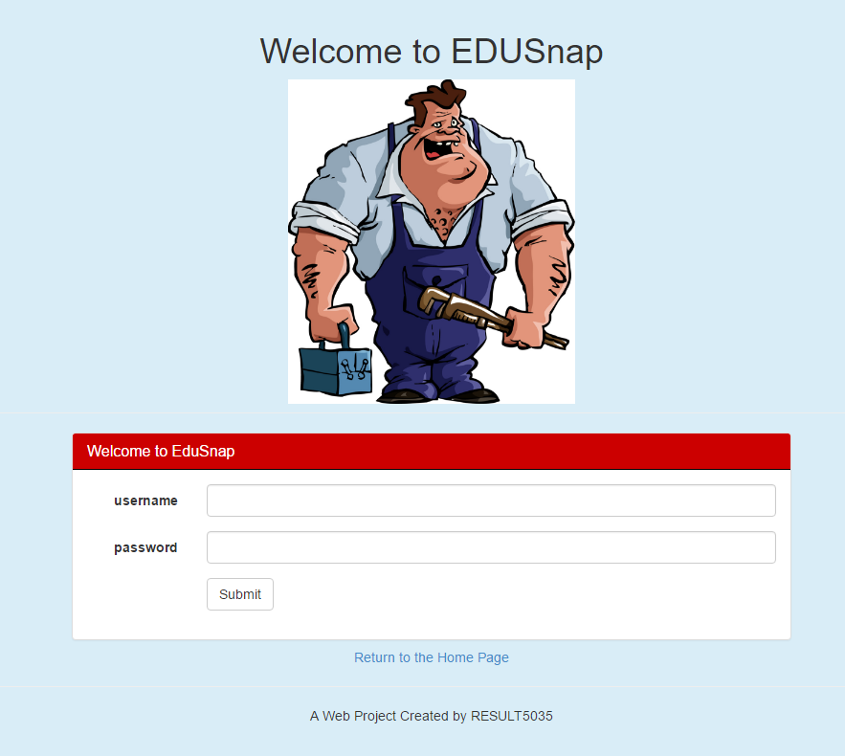

## User View

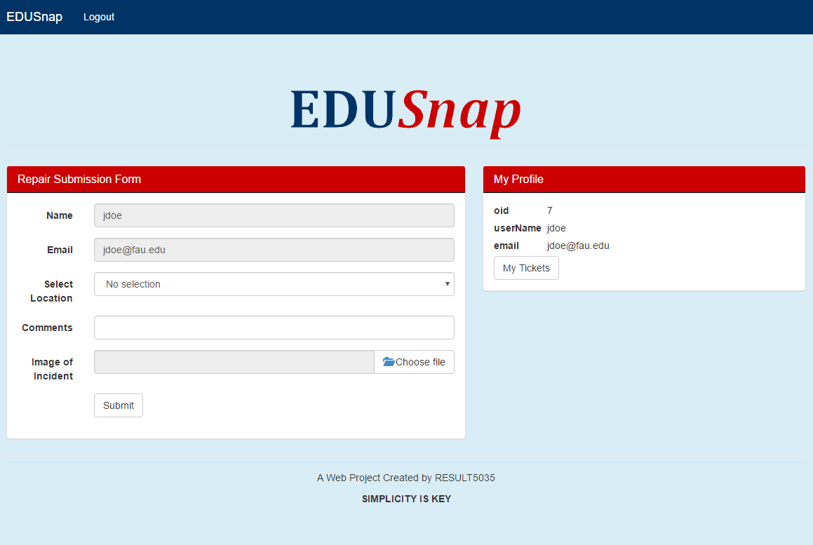

## Dispatcher View

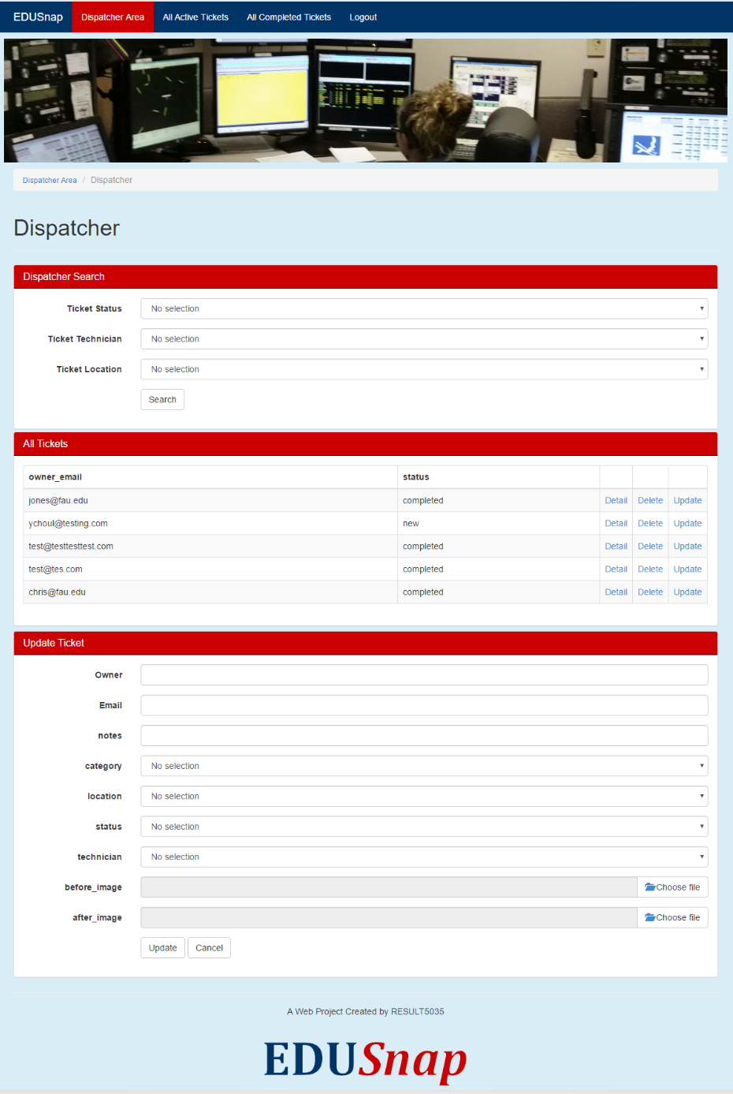

## Local Staff View



## Third-party View

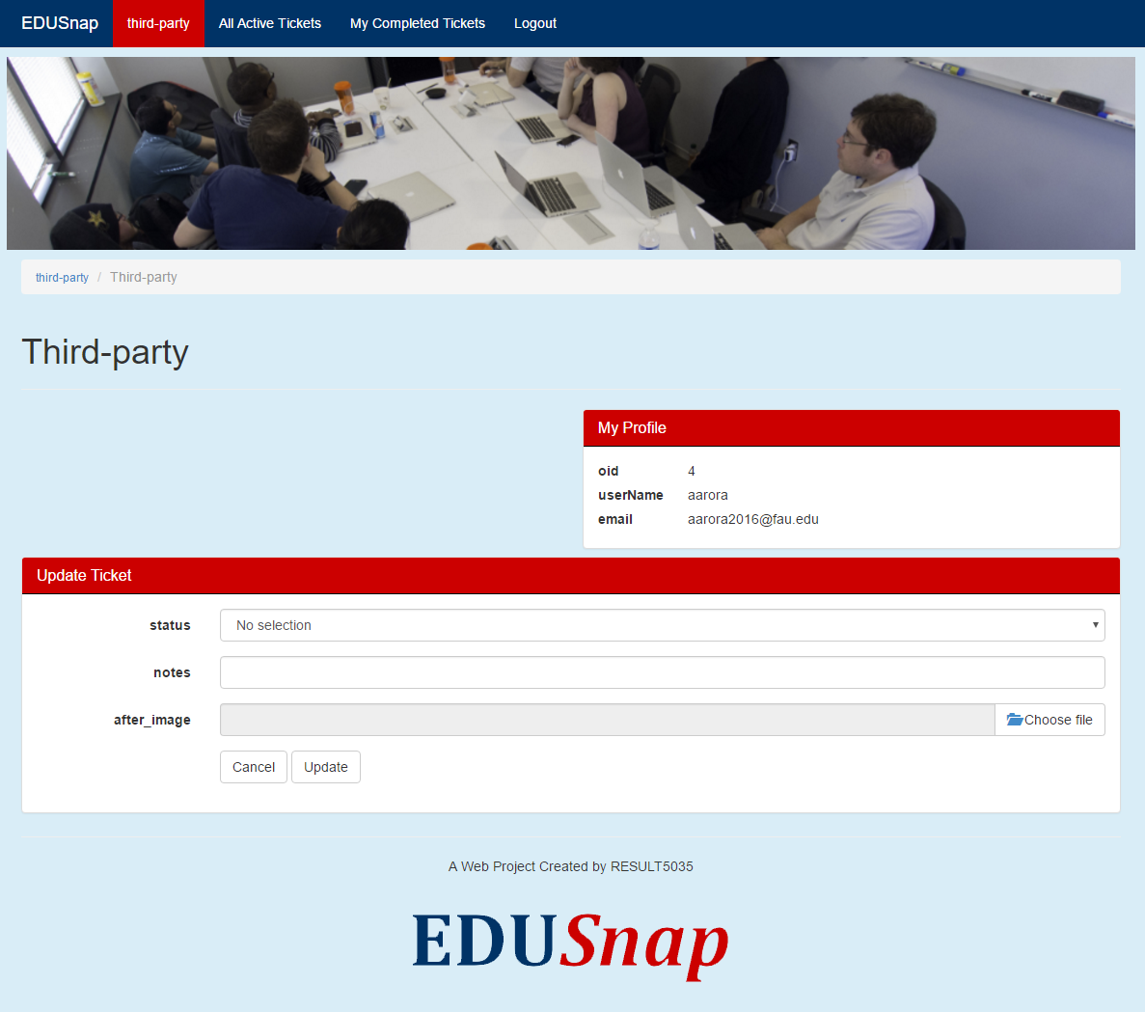

## Manager View

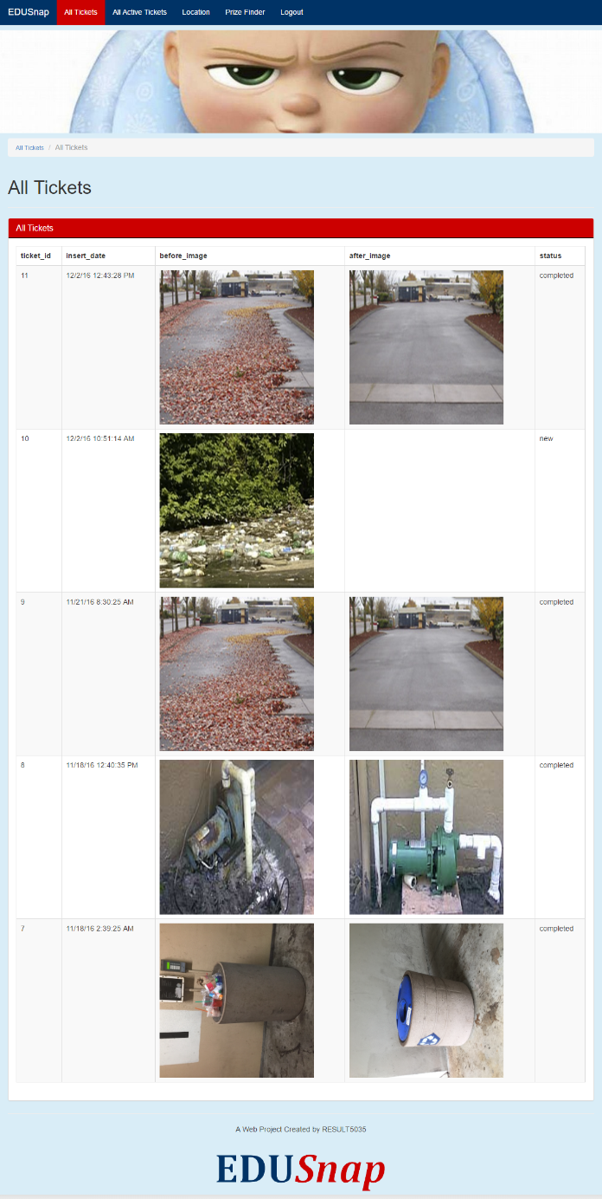

## Prize Finder Search

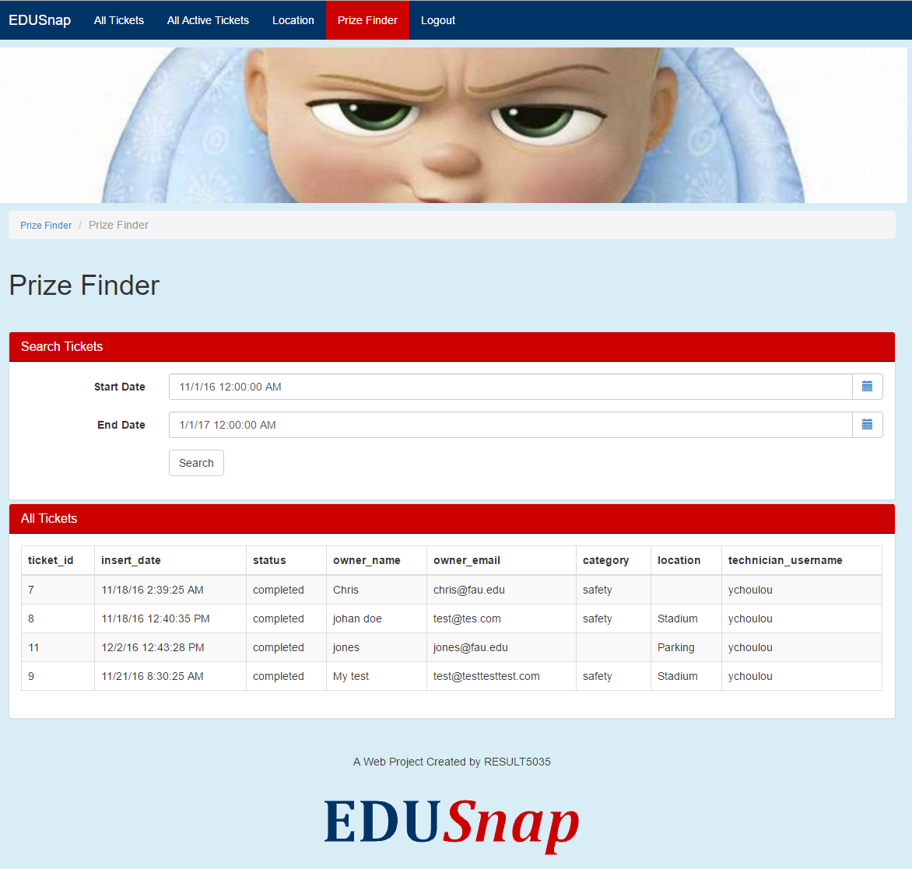

## Location Management

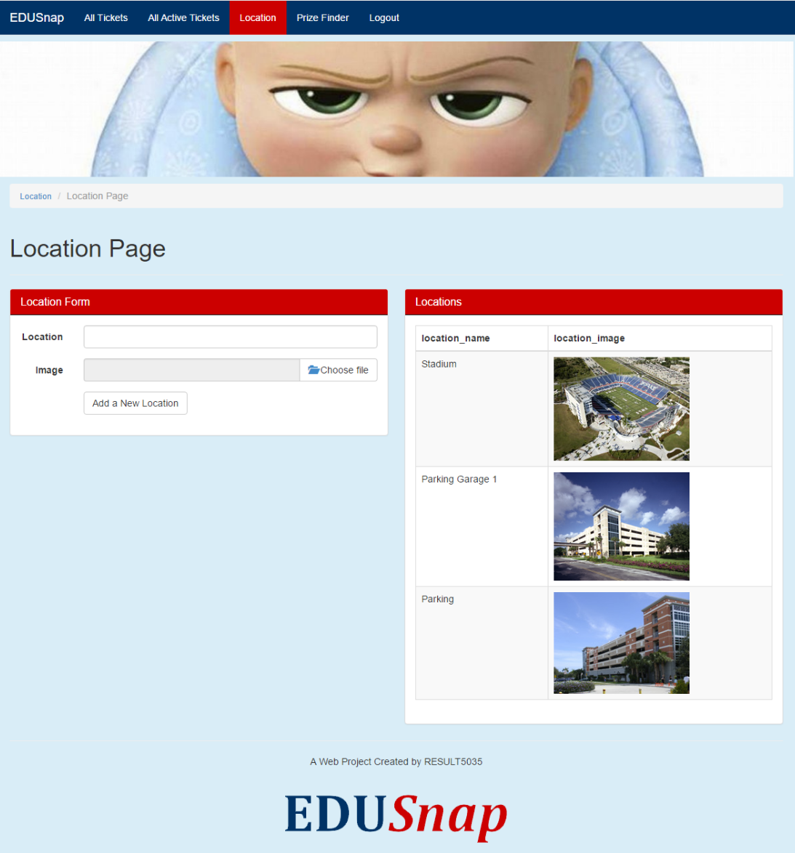

# **BPMN Diagram**

## Overview BPMN Process with all entities and actors

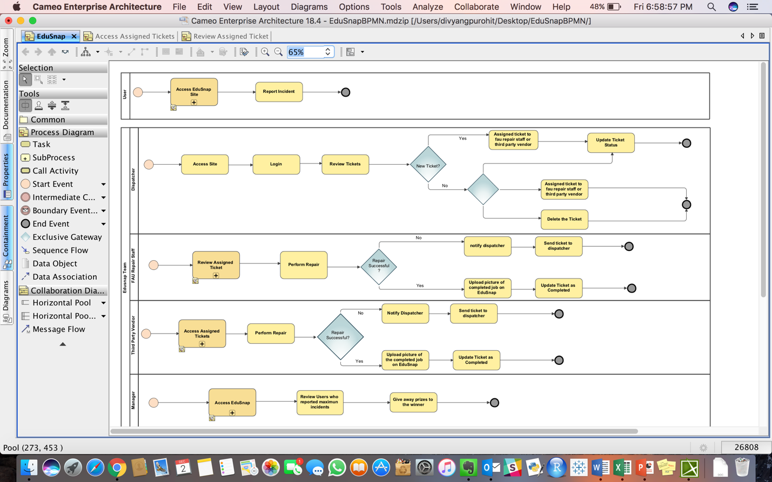

## Sub-process of User Accessing **EDU*Snap*** site

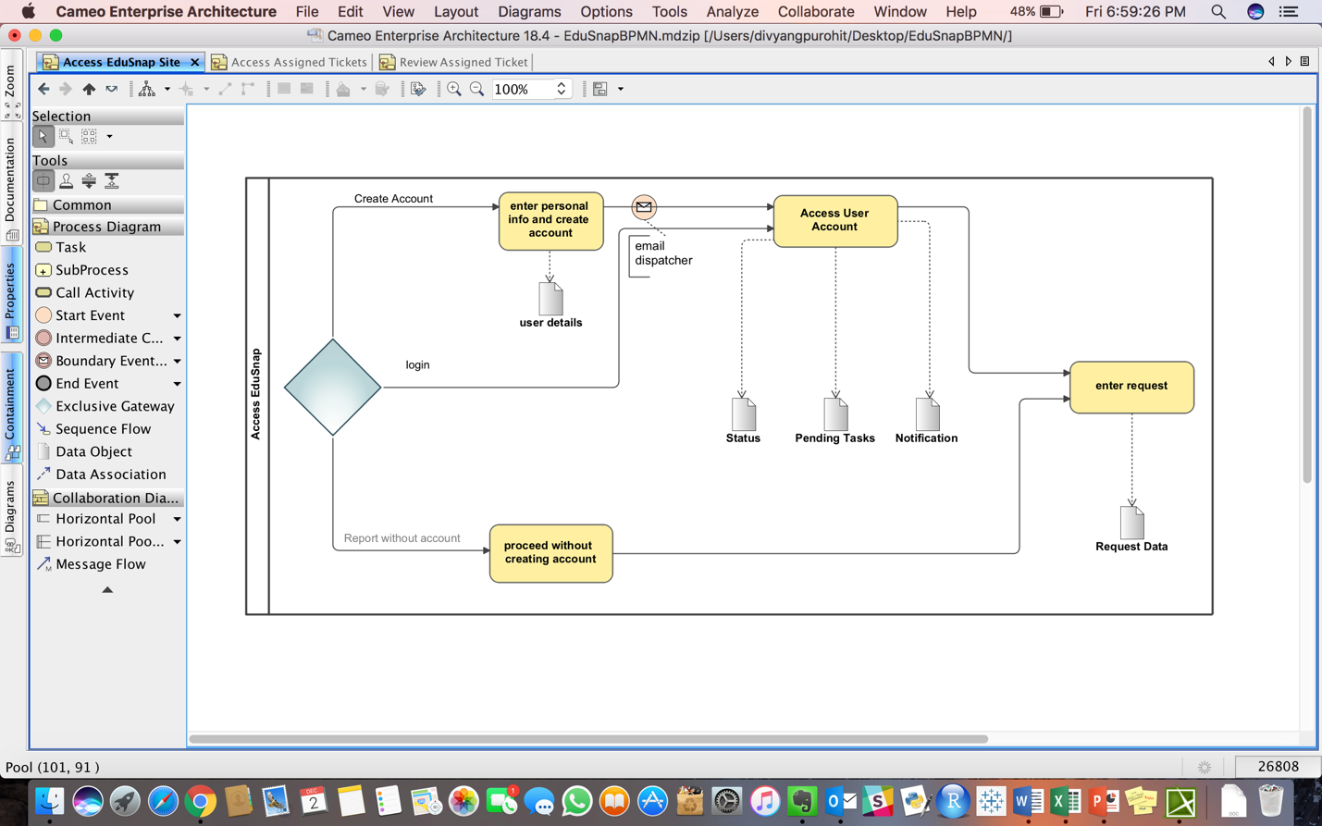

## Sub-process of dispatcher’s accessing the site

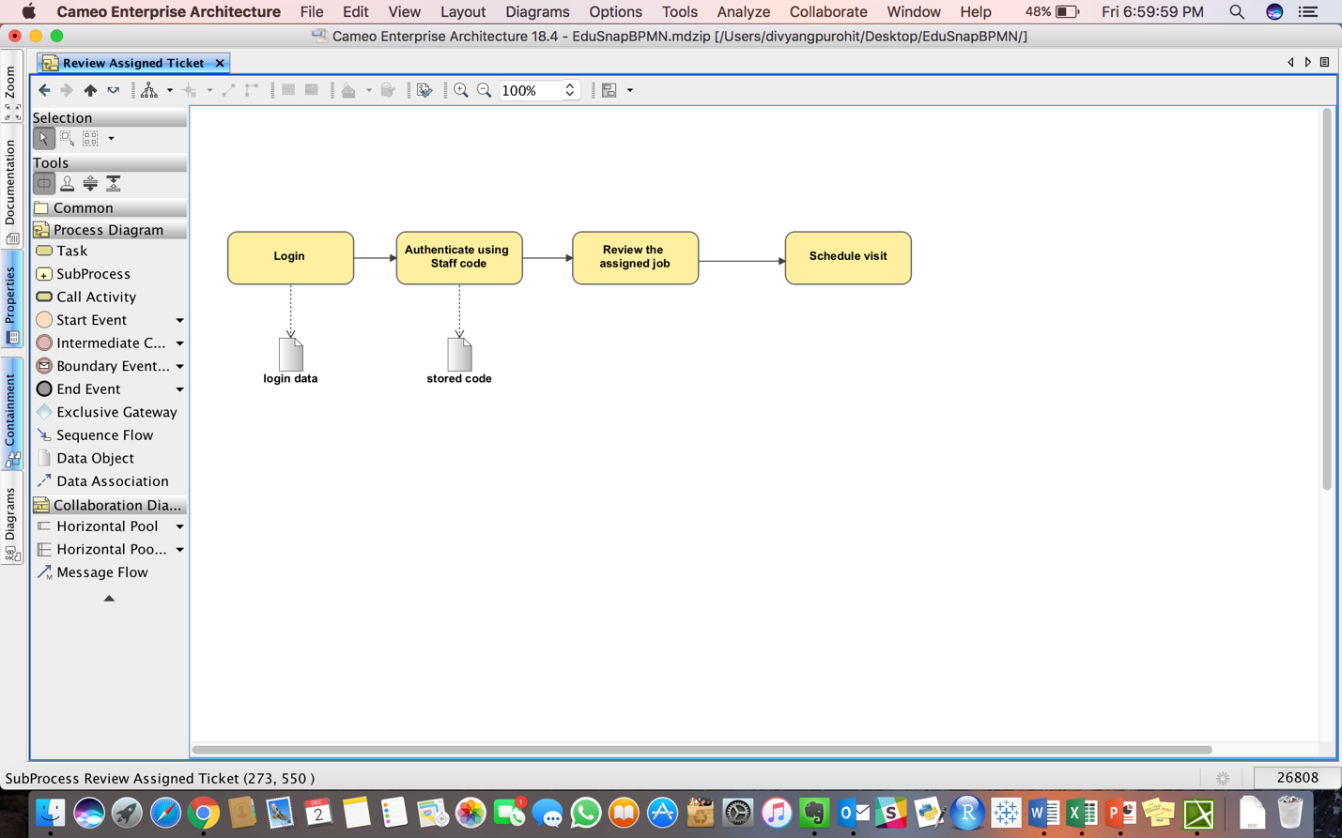

## Sub-process of FAU Repair Staff accessing the site

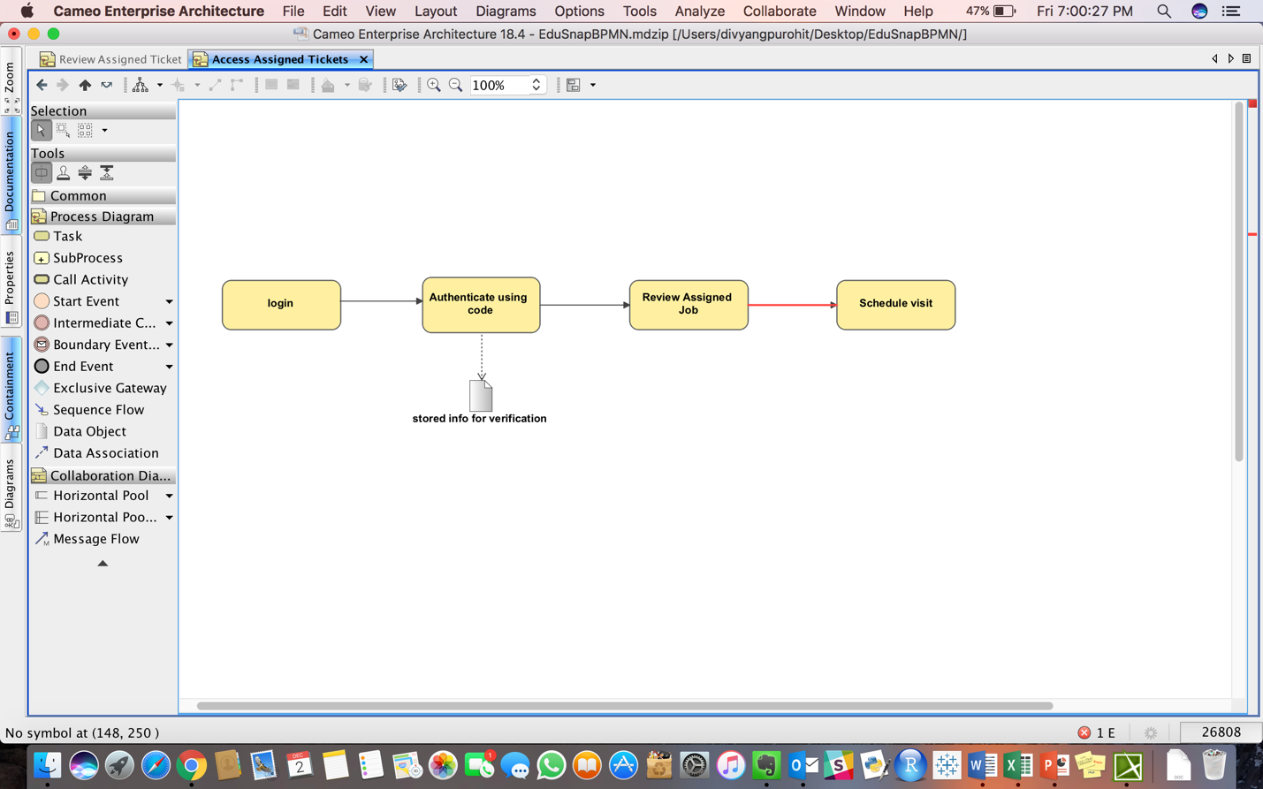

## Sub-process of Third Party Vendor accessing the site

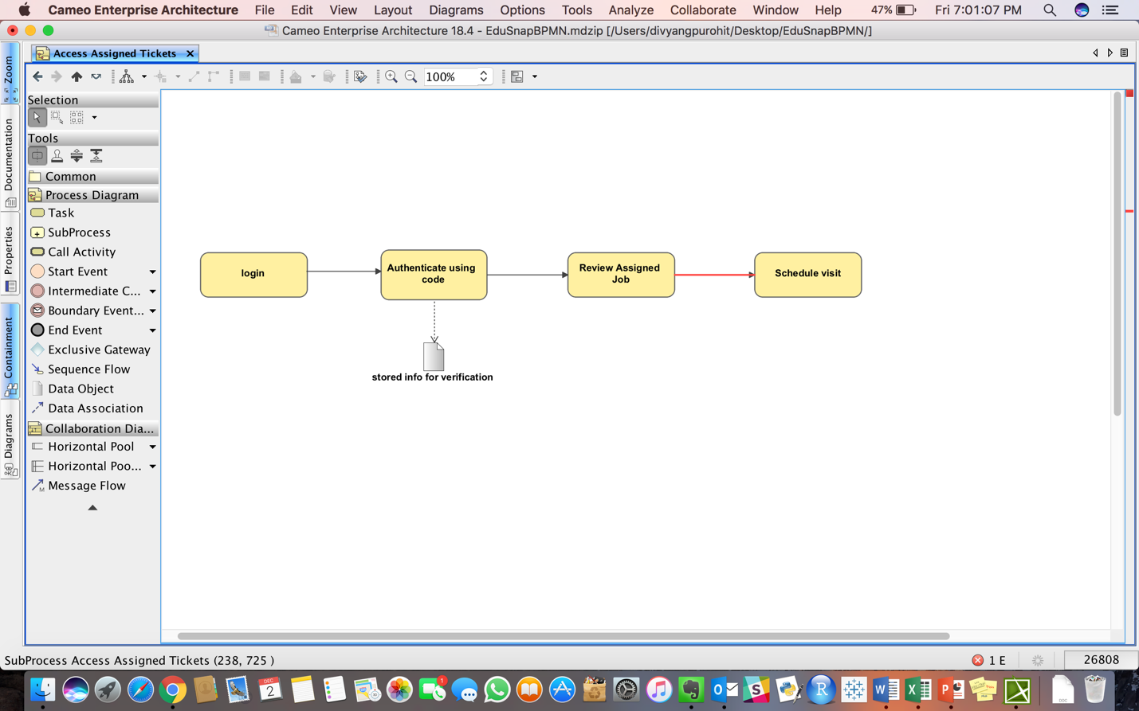

## Sub-process of Manager accessing the site

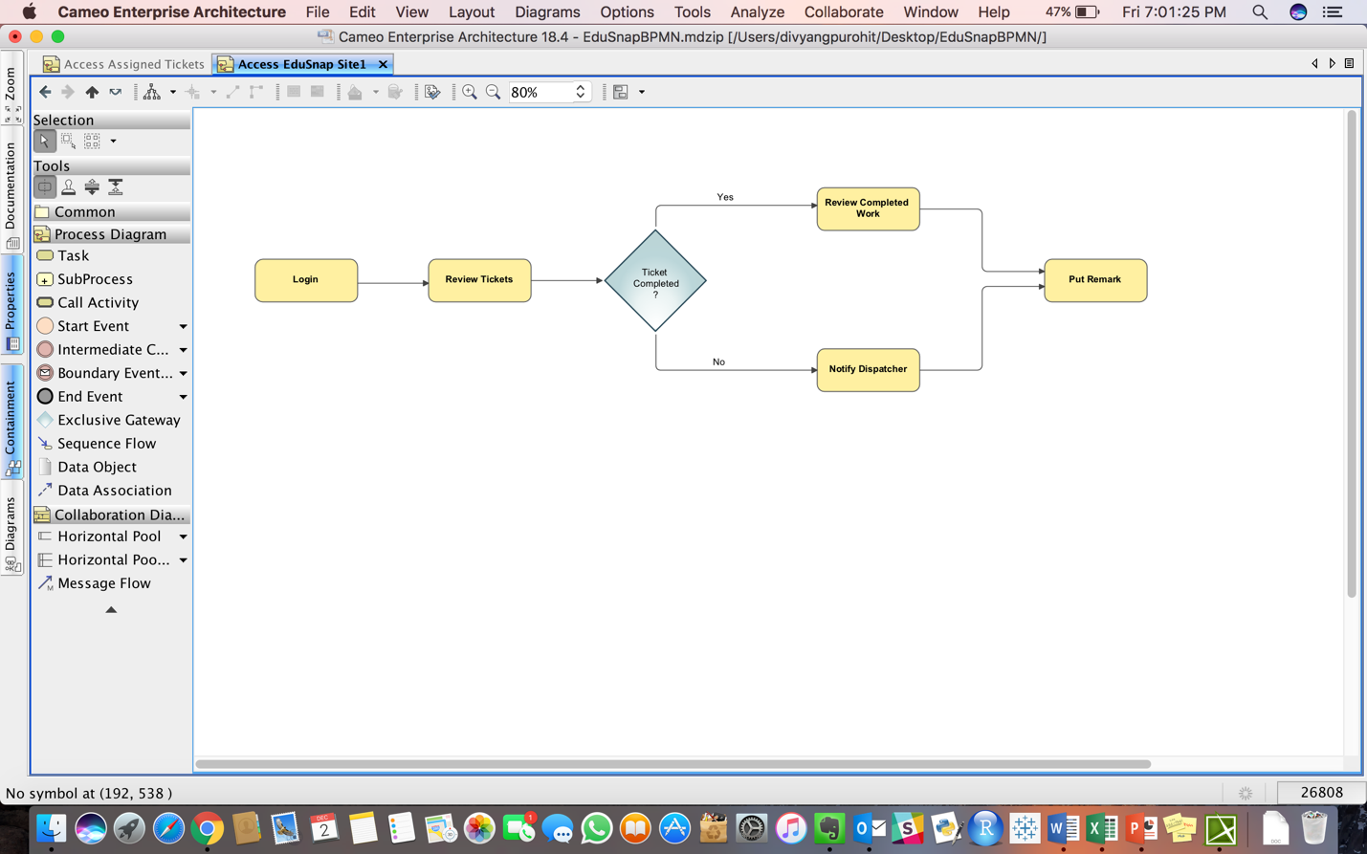

# **Scrum Project Screen Shots**

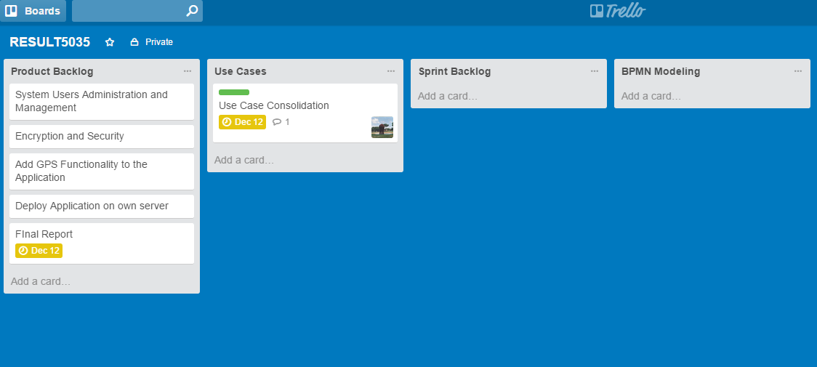

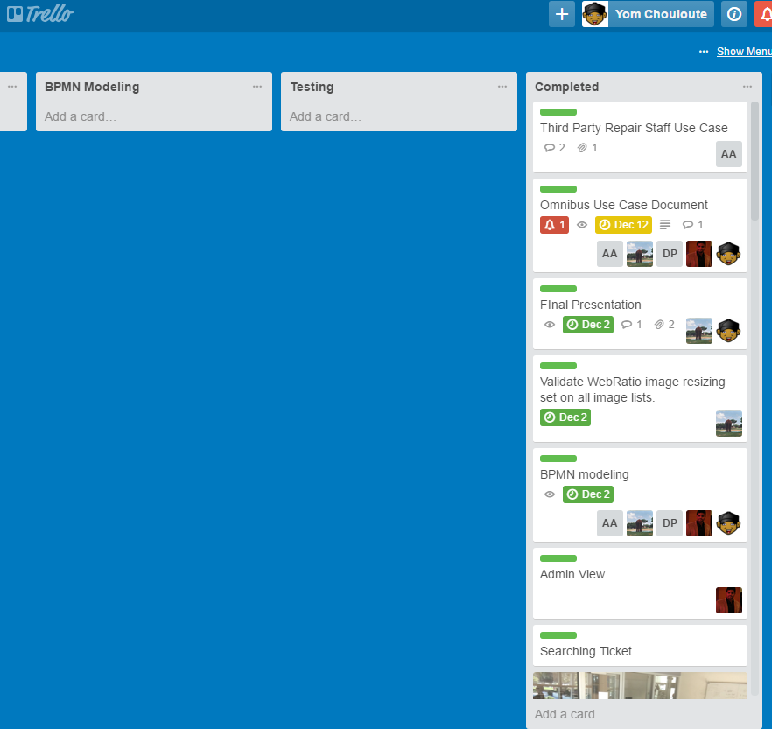

# **Features**

## Finished

* Ad hoc Ticket submission
* Email functionality
* User Registration and ticket history
* Dispatcher View
* Local Staff View
* Third-party View
* Manager View
* Ticket Search and prize Finder
* Before and after Pictures Feature.

## Unfinished & Wish List

* We would like to add GPS functionalities to the system so we can pinpoint the exact location of an issue.
* We would like to add user management portal, instead of adding users directly to the database
* We would like to encrypt the sensitive information in the database.

Reflections on Model Driven Development

Model development helps focus the development on users and objects and away from code. By starting our progress with the user flow we were able to develop a user centered application which made development easier. Using models we were able to visually determine flows and exceptions. Integration of new features and quick modifications were made by models. The use of models allowed us to develop products that use features that we may not have been trained to develop.

# **Knowledge Gained**

The team gained knowledge of a number of areas including:

* Software modeling
* Web Ratio
* Cameo Tools
* BPMN Diagrams
* Scrum (Product owner, scrum master….)

Most of us in the **EDU*Snap*** team have heard of Scrum and the agile development processes before but none of us had a chance to implement it in an actual. This class allowed us to get a glimpse at how scrum is being used in the real world.

We learned about a great deal of tools, such as Balsamiq, Trello, Jira, Github, Cameo, WebRatio, Circuit, testing tools. We also learned a few acronyms in the process. Acronyms such as BPMN, BPML, OMG, TDD, BDD, RUP, and so on…

Critical to our added knowledge was the difficulty of adding/changing tools at the beginning of a sprint. We also found out that communication is key component in the success of a software project. Google Drive, and Circuit came to our rescue. These tools provide the communication medium that was indispensable to get communication flowing among us.

Software Engineering has come a long way in the last few years. We are hoping that the OMG (Object Management Group) and other such organization can continue to work on developing high standards that can help us software professional develop good software that survive through the test of time.